* 1. **What Operating Systems Do**
* A computer system can be roughly divided into four parts –
* hardware: CPU, memory and I/O devices
* operating system
* application programs
* user

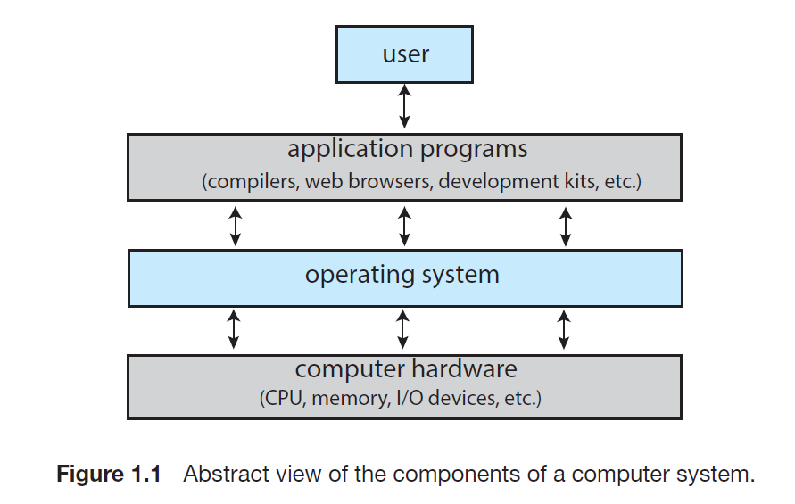

* **Moore’s Law:** The number of transistors in an integrated circuit would double every 18 months.
  1. **Computer System Organization**
* A modern general-purpose computer system consists of one or more CPUs and several device controllers connected through a common bus that provides access between components and shared memory.

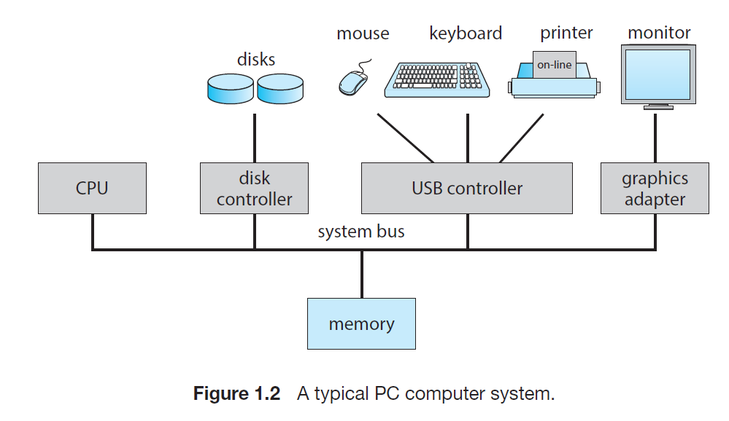

* **Device driver:** Operating systems have a device driver for each device controller. It understands the device controller and provides the rest of the operating system with a uniform interface to the device.
* **Interrupt:** Interrupts are handled as follows –
* When the CPU is interrupted, it stops what it is doing and immediately transfers execution to a fixed location.
* The fixed location contains the starting address of the interrupt service routine.
* The interrupt service routine executes.
* On completion, the CPU resumes the interrupted computation.
* **Interrupt Vector:** A table of pointers to locations that hold the addresses of the interrupt service routines for various devices.
* It is indexed by a unique number, given with the interrupt request, to provide the address of the interrupt service routine for the interrupting device.